
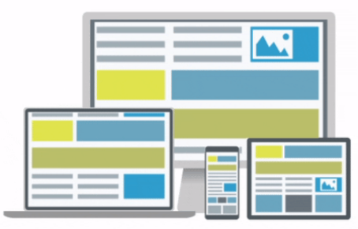
Bootstrap 5 The Next Generation of Web Development
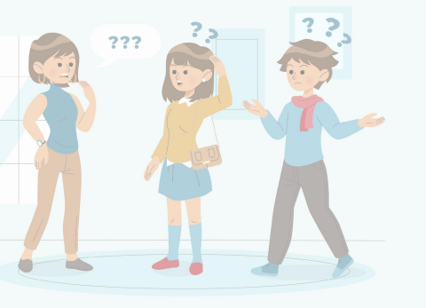
Before learning Bootstrap 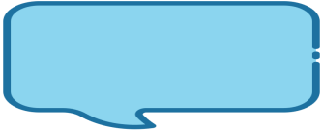HTML
CSS
Responsive Web Design

Responsive web design (RWD) is an approach to
web design that makes websites look good and
function properly on a variety of devices, from large
desktops to small smartphones.
What is Bootstrap
Bootstrap is a widely-used front-end framework used to build

responsive user interfaces.
It provides a collection of pre-built HTML, CSS and javascript
components and utilities.
Bootstrap simplifies the process of creating consistent and
professional-looking web interfaces by offering a wide range of ready
to-use UI components

History of Bootstrap

Bootstrap, originally named Twitter
Blueprint ,was developed by Mark Otto
& Jacob Thornton at Twitter.
Bootstrap was released as Open source
project on August19,2011
Responsive Design:
Benefits of Bootstrap Time Efficiency:
Bootstrap is built with a mobile-first
approach, ensuring that websites
and web applications created with it
are responsive and adapt well to
various screen sizes.
Consistency and Uniformity:
Bootstrap provides a wide range of pre-built components and templates, allowing developers to quickly prototype and build web interfaces.
By using Bootstrap, developers can ensure that
their websites have a cohesive look and feel, with consistent typography, spacing, and color schemes.
Cross-Browser Compatibility: Bootstrap has been extensively tested across different web browsers, ensuring compatibility and consistent rendering across major browsers
Customization:
Developers can easily modify and tailor the framework to match their project's specific requirements.
What's New in Bootstrap 5
Enhanced grid system: More
flexible and customizable grid
layout.
Updated default typography:
Improved default typography
for better readability.
Reimagined forms:
Redesigned form controls and
validation styles.
Removed jQuery dependency: Bootstrap 5 no longer relies on jQuery.
New utility classes: Additional utility classes for spacing, sizing, and more.
How to Get Started with Bootstrap 5
Set Up Your Development Environment:
Make sure you have a text editor or integrated development environment (IDE)
installed on your computer. Popular choices include Visual Studio Code, Sublime Text.
Download Bootstrap:
Visit the official Bootstrap website at https://getbootstrap.com/.Click on the "Download" button to download the latest version of Bootstrap.
You have two options: download the compiled CSS and JavaScript files or download the source files to customize and compile them yourself.
Link Bootstrap in Your HTML File:
Create a new HTML file or open an existing one in your preferred text editor. In the head section of your HTML file, include the Bootstrap CSS file
Just before the closing </body> tag, include the Bootstrap JavaScript file. Start Using Bootstrap Components:

